OSSP (Operating Systems And Systems Programming) - 25CS2104E

PRACTICAL-3:
Roll No. : 2520030183
Name: N. Yeswanth Kumar
SEC-8

Aim: Develop a C program using fork() that creates a parent and child process. Display the Process ID (PID), Parent Process ID (PPID), and process states at different stages of execution.
Design an experiment to observe process state transitions (Ready, Running, Waiting, Terminated) using Linux monitoring tools such as ps, top, and /proc. Document the observations

PROCEDURE :
- Running & waiting :
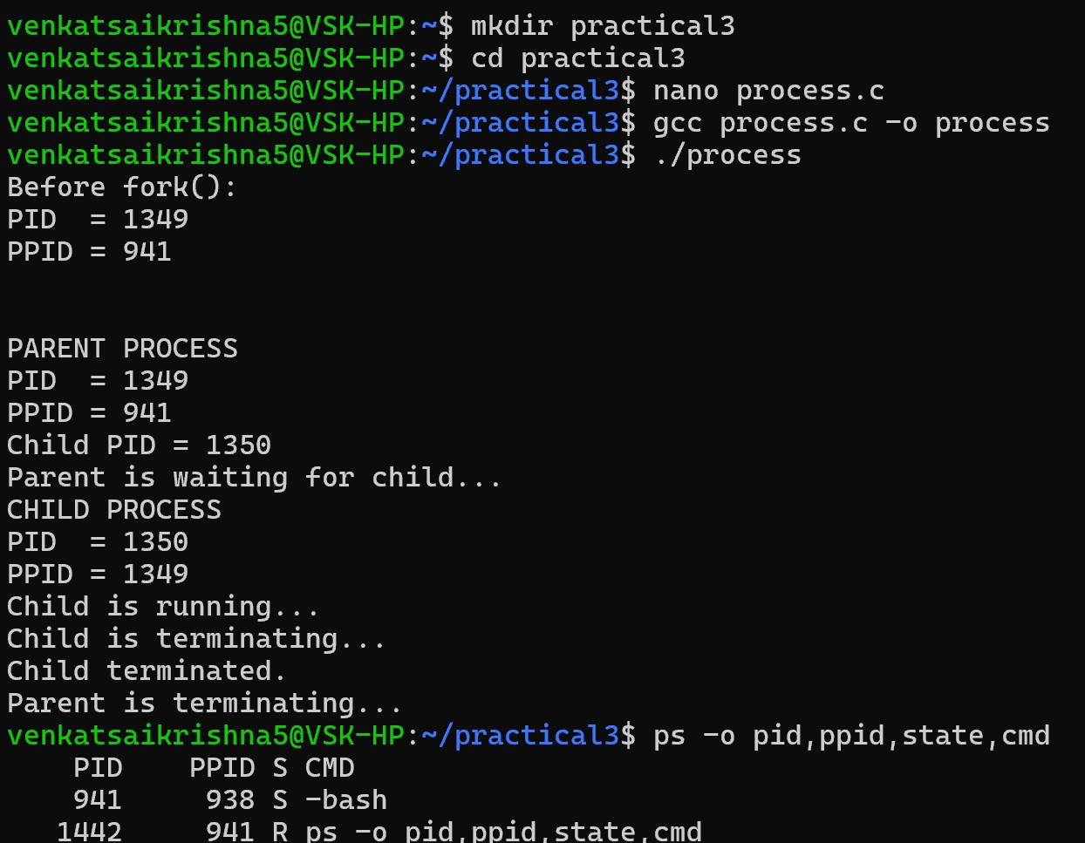

Monitoring:
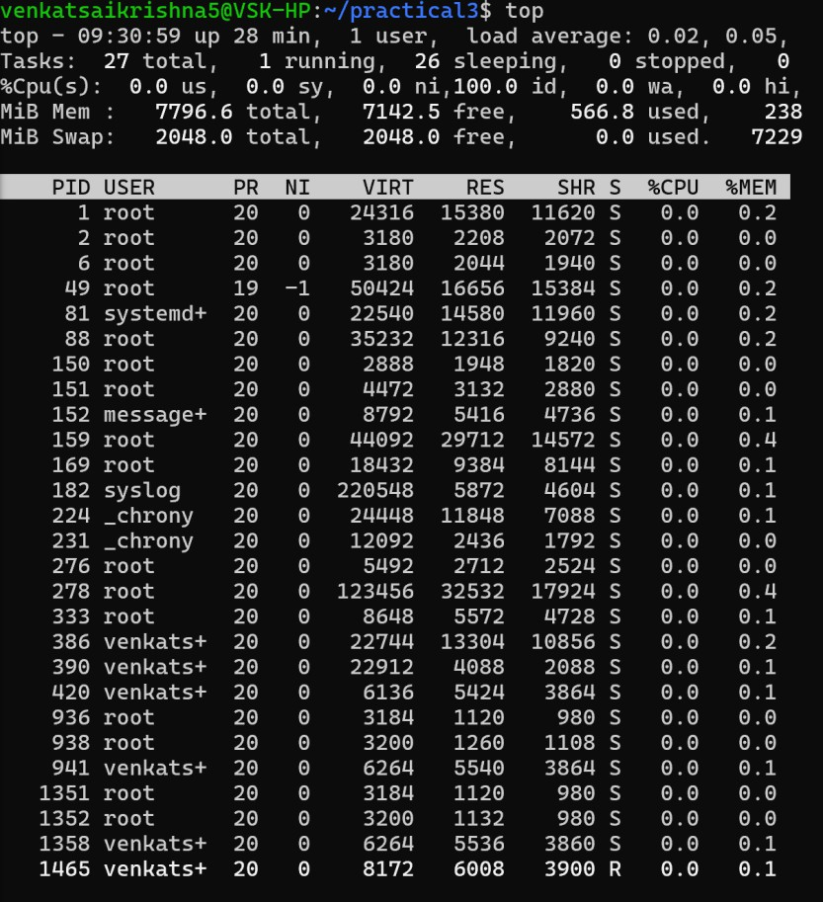

Terminated:
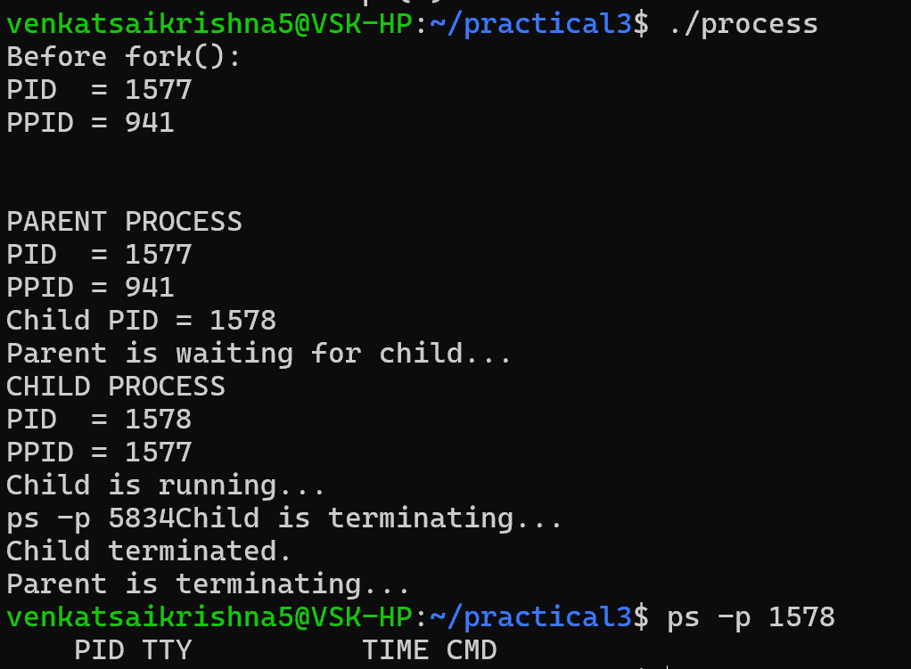

Code:
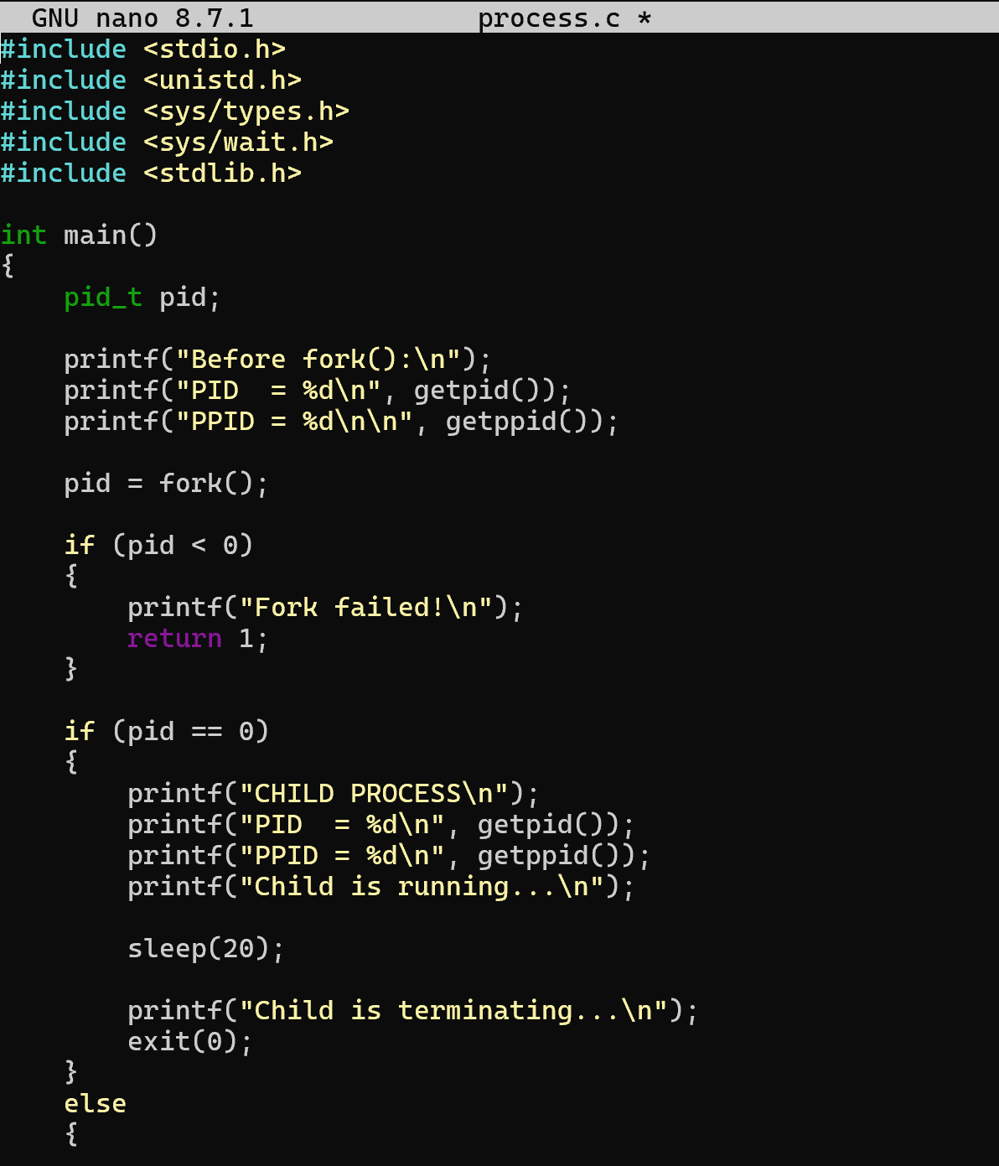

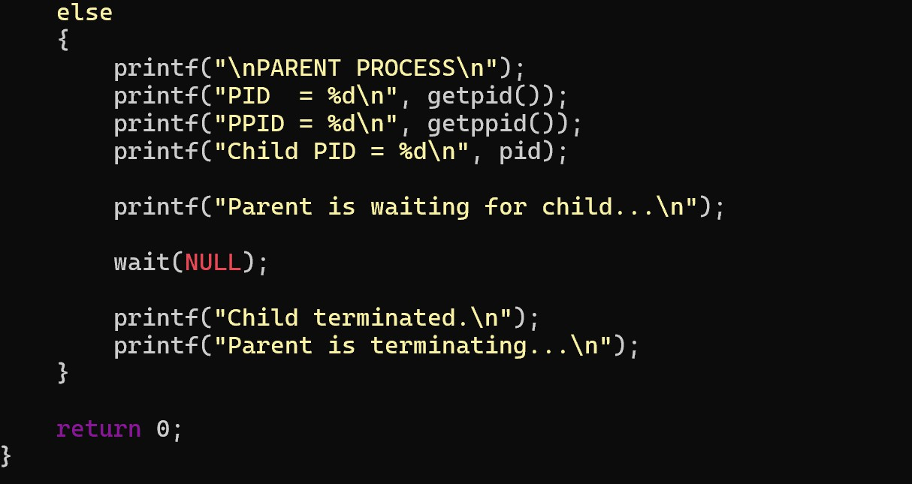

Observation :
  - A parent process and a child process were created successfully using fork().
  - The PID and PPID of both processes were displayed.
  - The child process entered the waiting/sleeping (S) state during sleep().
  - The parent process waited for the child using wait().
  - Process information was successfully observed using ps, top, and /proc.
  - After execution, both child and parent processes were terminated.

Result :
The experiment was successfully completed. The parent and child processes were created using fork(), and their PID, PPID, and process states were observed using Linux monitoring tools. The transitions between running, waiting, and terminated states were successfully verified.

